**Ahsan Aamir 200938**

**Subject:**

Computer Networks

Lab

# Assignment # 1

## Question 1:

## Calculate IP Addresses produced after applying the “formula (mathematical calculation for each IP)”. Identify Class, Private/Public, Valid/Invalid and Reserved/Not Reserved for each of calculated IP Address.

#### 1) 188.138.88.38

* Class B
* Valid
* Public
* Not Reserved

#### 2) 126.76.26.76

* Class A
* Valid
* Public
* Not Reserved

#### 3) 64.14.114.14

* Class A
* Valid
* Public
* Not Reserved

#### 4) 2.152.52.52

* Class A
* Valid
* Public
* Not Reserved

#### 5) 190.90.140.90

* Class B
* Not Valid
* Public
* Not Reserved

## Question 2:

## From the IP Addresses calculated in the “Question 1” use the 2 nd , 3 rd and 4 th octet for constructing new IP addresses with “127” as the 1st Octet. Then perform any of the 3 options of the PING command on each of the IP Addresses. Insert the screenshot for each part.

### 1) 127.138.88.38

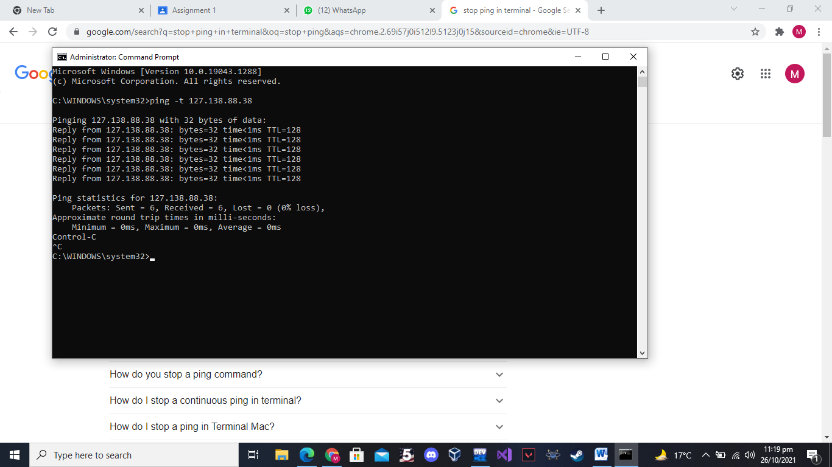

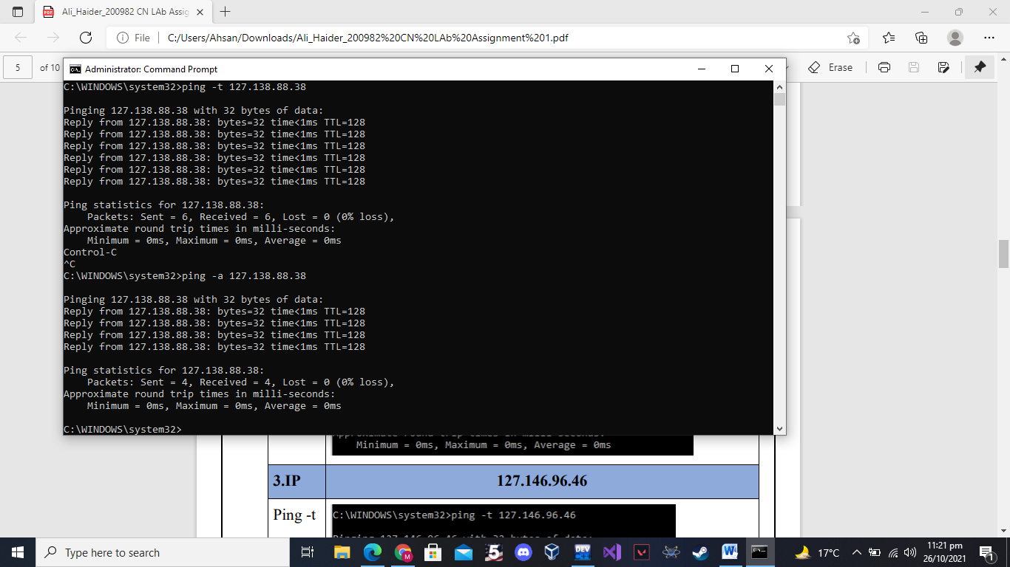

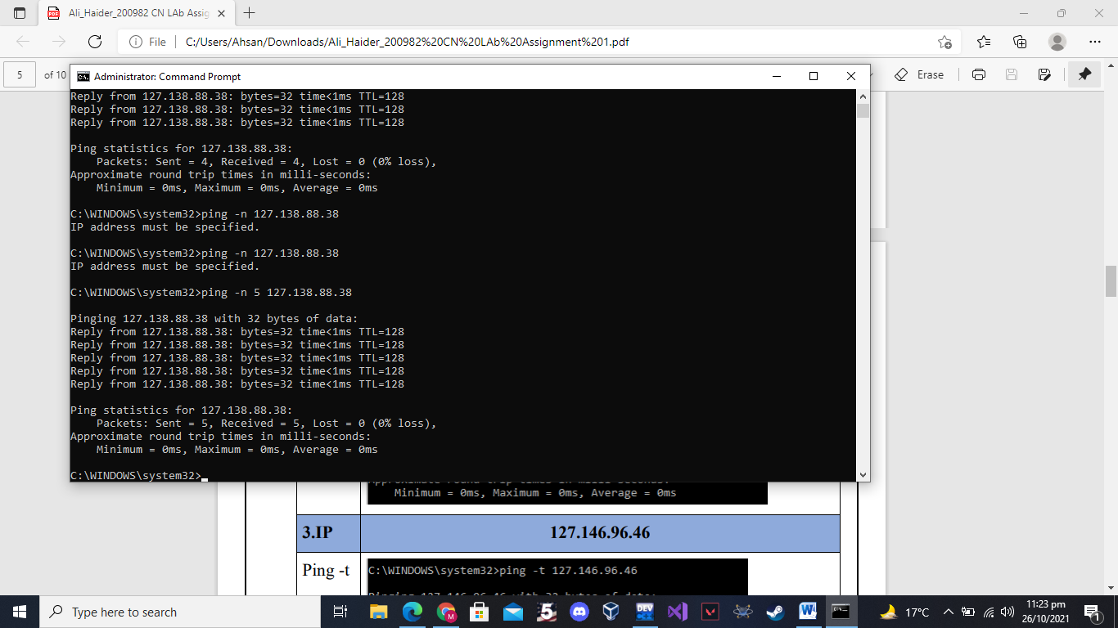

### 2) 127.76.26.76

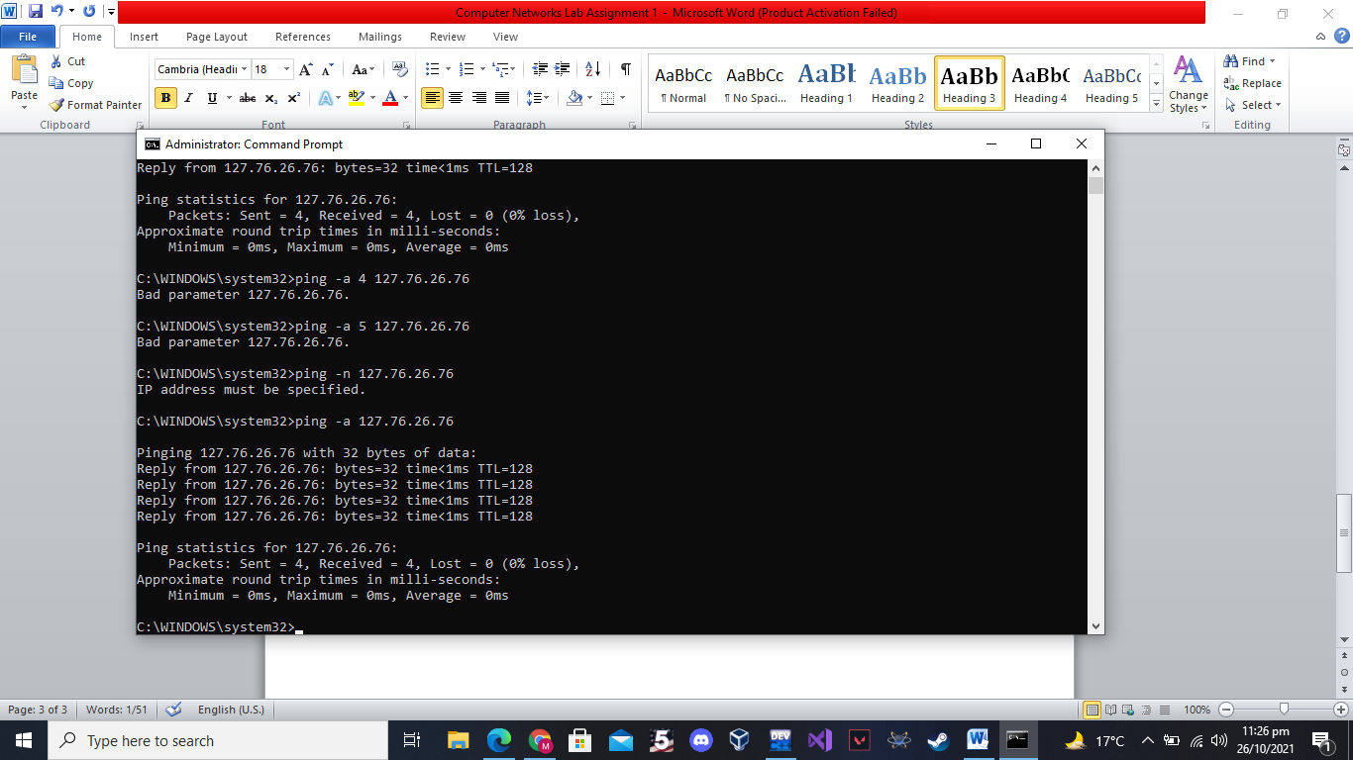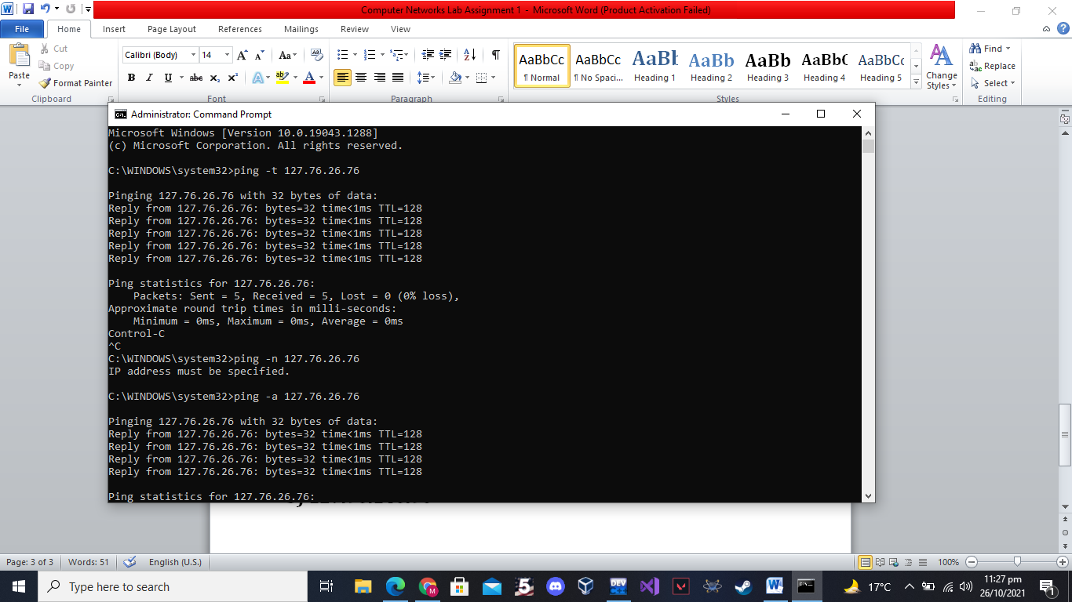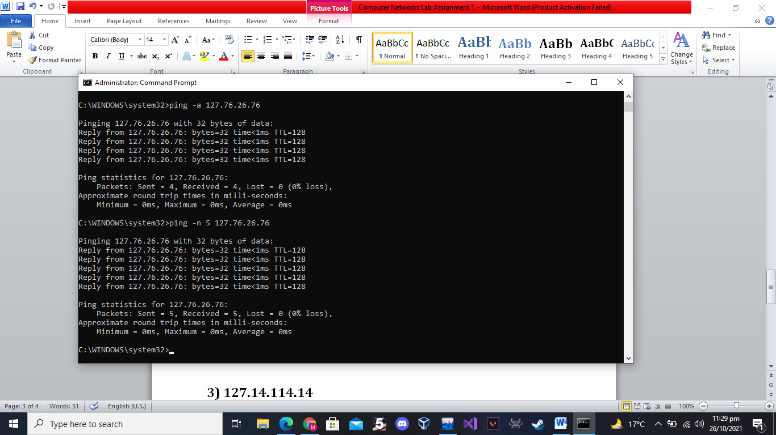

### 3) 127.14.114.14

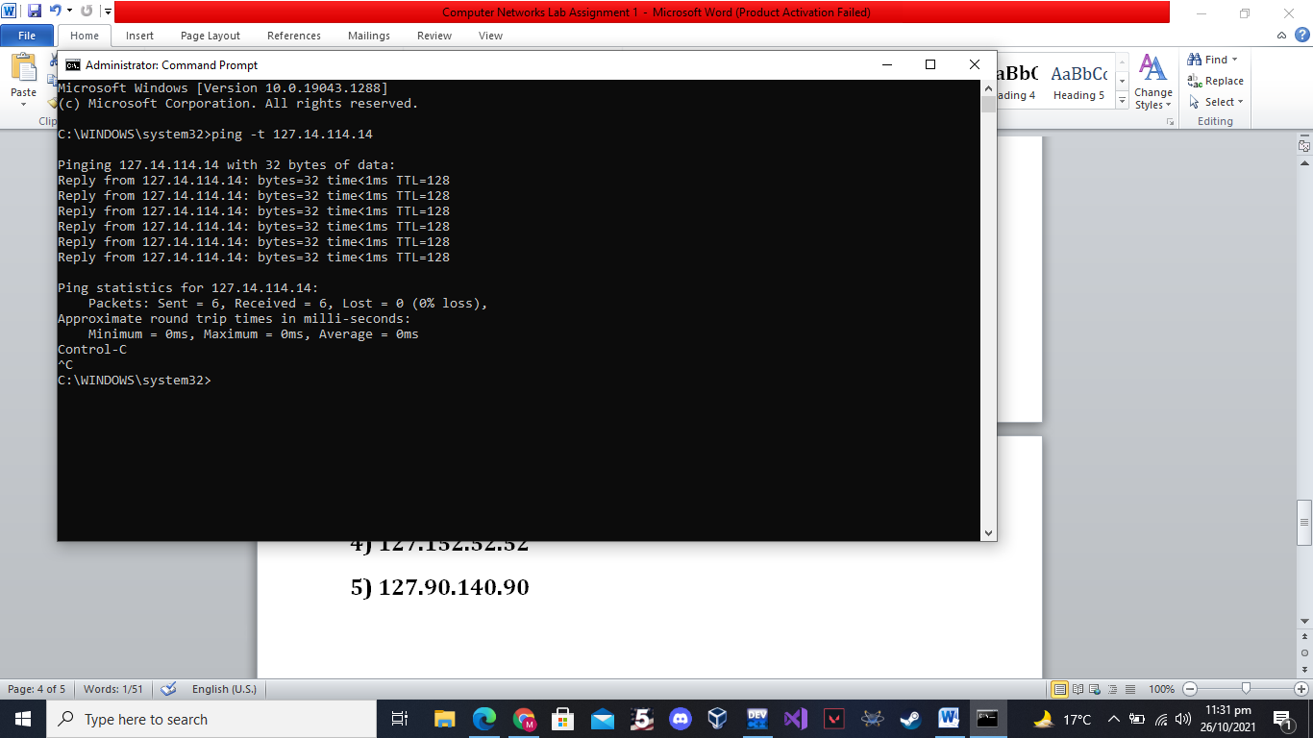

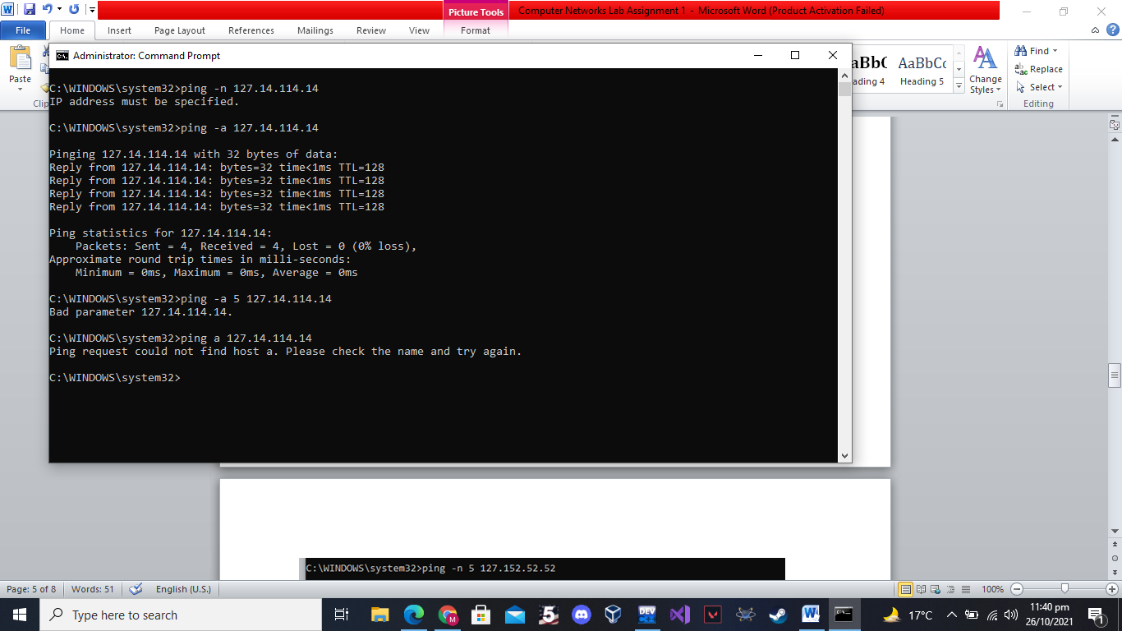

## 

### 4) 127.152.52.52

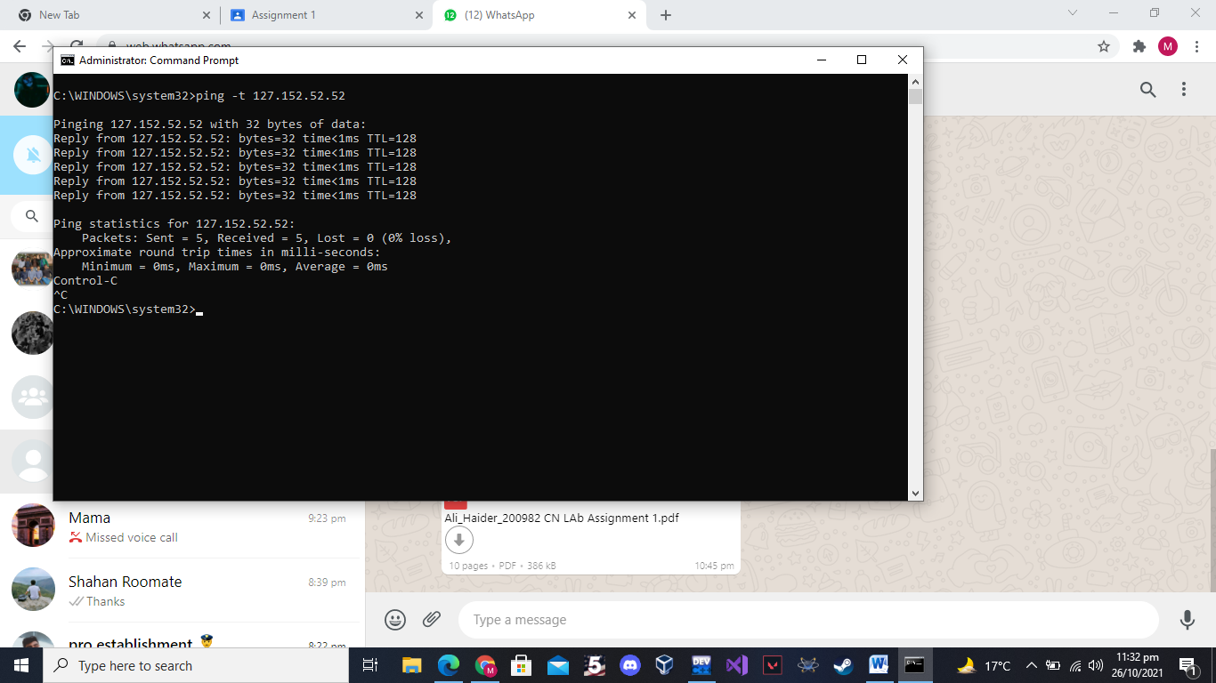

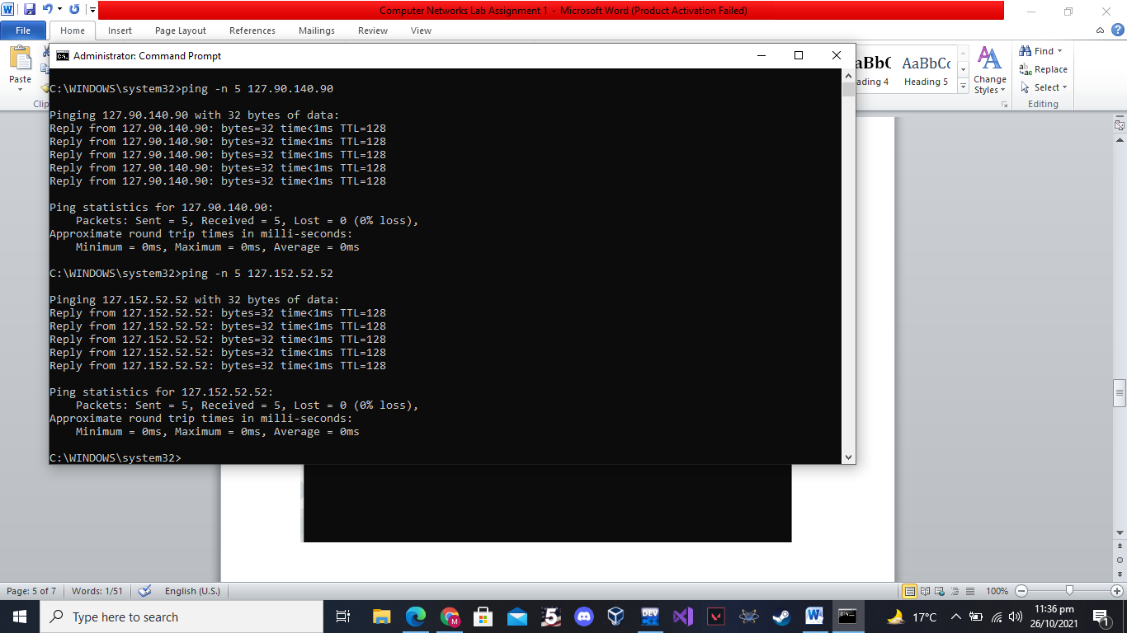

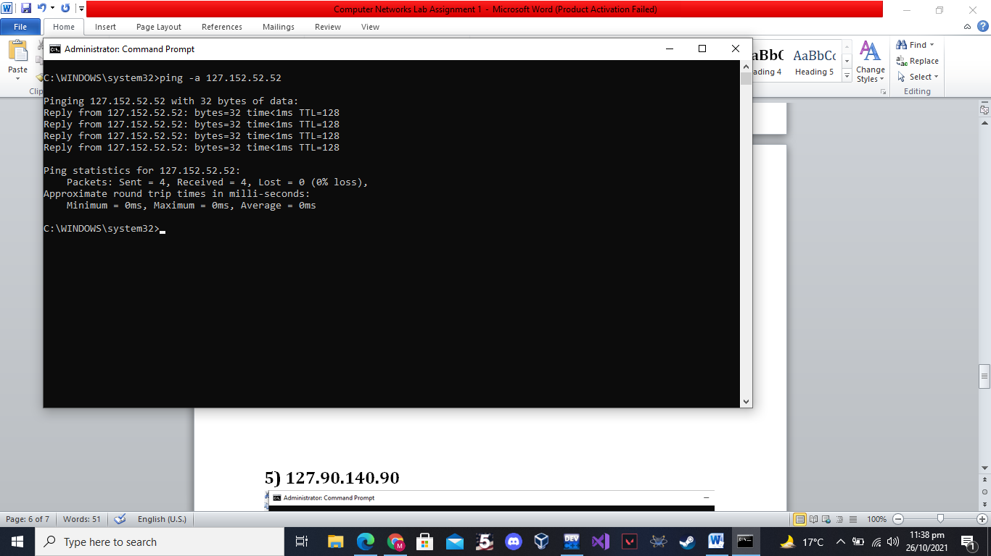

### 5) 127.90.140.90

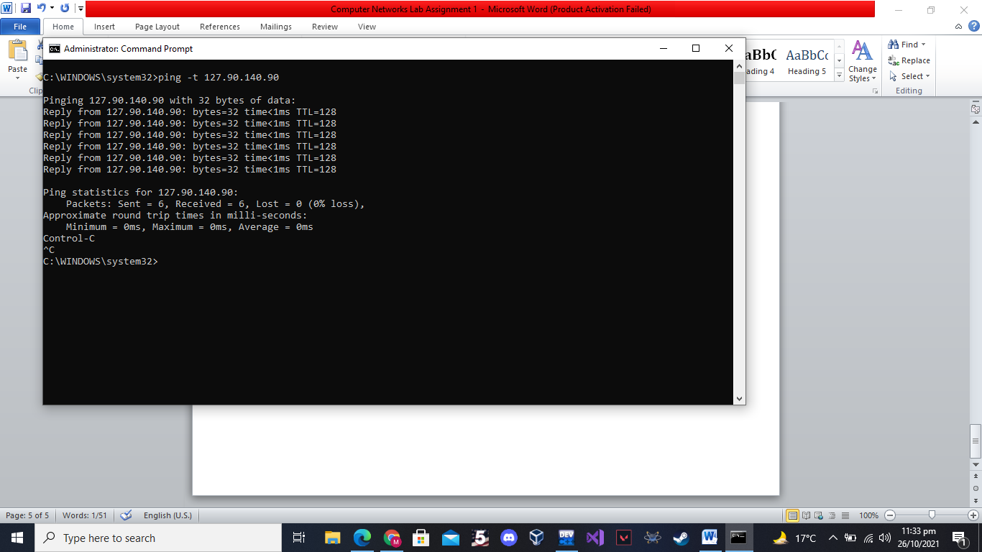

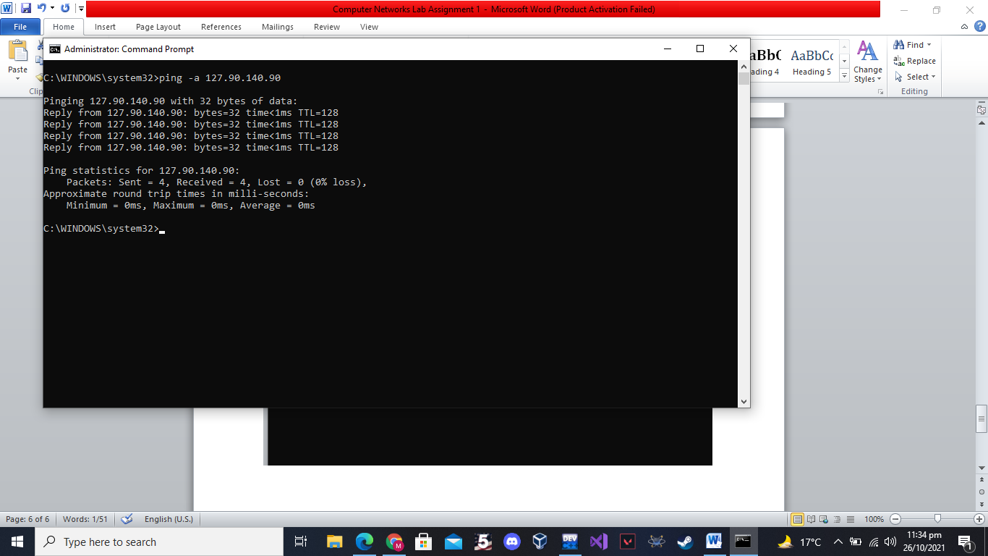

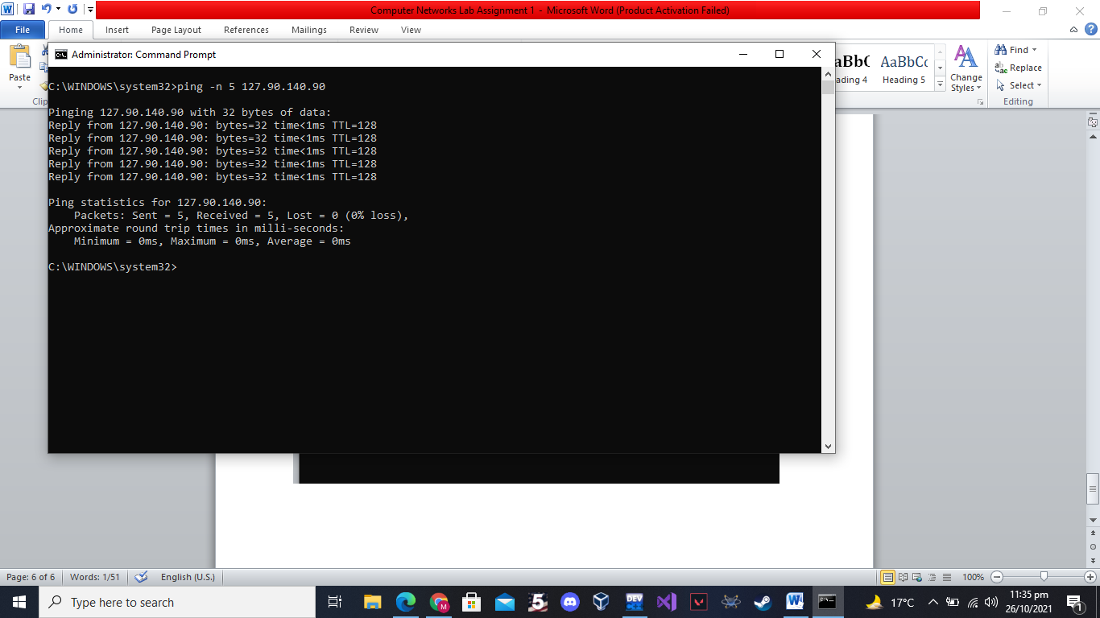

## Question 3:

## Find Trace route of Google, Yahoo, Facebook, Instagram and WhatsApp using the tracert command (use “.com” as the domain for each site, e.g. whatsapp.com). Use any of the 3 options of tracert for each website. Insert the screenshot for each part.

